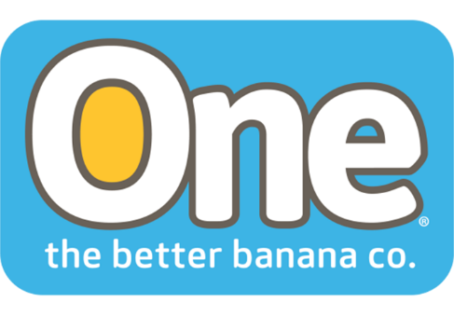
One Banana Invests in the Health and Well-Being of Employees
Coral Gables, Florida 24, 2018 – The United Nations Sustainable Development Goals (SDGs) are a blueprint to achieve a better and more sustainable future for all. One of the goals is Good Health and Well Being for All. One Banana, a family-owned tropical fruit operation with farms and packing plants in Central and South America, has aligned their CSR initiatives with the UN Sustainable Development Goals and several of their programs address this goal of health and well-being.
Medical Services
The ONE Banana commitment to the goal of Health and Well Being for All goes beyond their own employees. One Banana operates a medical clinic as part of a comprehensive vision to provide access and health coverage in the area of influence of their operations. The clinic is located in the Southwestern region of Guatemala, where more than 30,000 people live.
In this region of Guatemala, the number of cases of chronic diseases is increasing. Pedro Tzumil (59) is a local resident who was first diagnosed with Diabetes 15 years ago, when the disease had already caused serious circulatory problems in his legs. He had to have his lower left leg amputated. Getting around on crutches made it difficult to work and provide for his family.

In 2016, FUNSALUD, a foundation of One Banana, in coordination with Project ROMP, held an evaluation day for patients with amputations. Of the 19 people who attended 90% were diabetics. They were all evaluated clinically and had laboratory testing done at no charge. Don Pedro was one of the five who qualified for a prostheses and on January 26, 2017 he got his new prosthetic leg.

“It changed my life,” says Don Pedro. “I can walk and drive a car again. I can live and work as I did before. That's important for me and my family, all thanks to One Banana.”

Growing Up Healthy and Healthy Mothers Programs

Another initiative of One Banana’s CSR programs focuses on women and children.
In partnership with the University of Colorado (www.ucdenver.edu) ONE Banana’s Growing Up Healthy and Healthy Mothers programs aim to reduce mother-child mortality and to contribute to the growth and development of children during the critical zero-to-two years of age stage.
In 2017, University of Colorado physicians provided 12 training sessions to the technical personnel of ONE Banana who implement these community programs.
Both programs consist of training and home visits to regularly monitor the mothers and children involved The One Banana team of professionals who coordinate, execute and monitor the programs specialize in nursing and community relations.
The ONE Banana monitors make household visits to provide training and check on the children’s development and growth. In 2017, 115 children successfully completed the program and showed satisfactory growth and nutritional development. In 2017, 613 children attended this program and 4,530 household visits were made.
The Healthy Mothers program is aimed at pregnant women and teaches them to identify danger signals during pregnancy, practice good pre-natal care, recognize post-partum depression, see danger signals in new-born babies, provide adequate nutrition and support for breast-feeding. The program offers medical exams during pregnancy and household visits after birth. In 2017, there were 312 mothers active in the program and 982 household visits were completed.
All the One Banana health programs are directly aligned with the UN vision for providing health and well-being for all by 2030. As these results from their 2017 Sustainability Report show, they’re already making significant headway in their corner of the world.
About One Banana
ONE Banana is a sustainable grower, shipper and distributor of tropical fruit with operations in the United States, Guatemala, Europe, Peru and Ecuador. It has emerged as a leader in socially responsible and environmentally sustainable farming. For more information about ONE Banana please visit our website https://www.onebananas.com
Contact information: info
###

