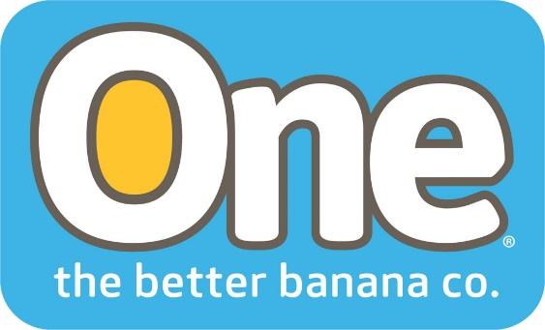

One Banana Making a Difference with Food Security Programs
Coral Gables, FL. October 16, 2018. World Food Day marks the founding of the Food and Agriculture Organization of the United Nations in 1945. It’s observed by many organizations involved with food security around the world. One Banana’s CSR programs are closely aligned with the UN Sustainable Development Goals (SDGs) and several of their program address this issue.
Food security is defined by the UN as the condition in which all people, at all times, have physical, social and economic access to sufficient safe and nutritious food that meets their dietary needs and food preferences for an active and healthy life.
One Banana’s Living Wage program addresses the economic conditions of their workers with the goal of giving them the wherewithal to provide sufficient nutritious food for their families. The company is the first in Guatemala to carry out research to establish what workers require to provide their families with food security and a healthy, active life.
Another program aligned with this goal is the Healthy Children Program. “The children who reach satisfactory growth and nutritional development parameters by the age of three graduate from the program each year,” said Robert Adams, President of One Banana. In 2017, 115 children completed the program.
The Nutritious School Meal Program (A banana a day makes a difference) helps improve the nutrition and food security of children as part of an education program. The program consists of the donation of bananas to schools near One Banana plantations. More than 160,000 bananas were donated this year and 8,401 children at 34 rural schools in Guatemala Southwest and South Coast benefited from this program.
The program aims to reduce child malnutrition through medical check-up events, training for mothers, teachers, and children on a nutritious and balanced diet and preventive health. The growth and development of children in these schools is closely monitored.
Bananas are easy to digest, contain vitamins and minerals, and help prevent conditions such as anemia and high blood pressure. Good nutrition has been shown to be a contributing factor to school performance. Children receiving the banana snack showed improved academic performance in mathematics and language at the end of the program. Unilever recognized this program with their Big Tick award given to companies that make a positive difference in society.
Given population growth and rising incomes, it is estimated that the demand for food will rise by 70 to 100 percent by 2050. One Banana will continue to implement food security programs to help their employees and adjacent communities have access to sufficient safe and nutritious food that meets their dietary needs and food preferences, so they are able to lead healthy and active lives.
About One Banana
ONE Banana is a sustainable grower, shipper and distributor of tropical fruit with operations in the United States, Guatemala, Europe, Peru and Ecuador. It has emerged as a leader in socially responsible and environmentally sustainable farming. For more information about ONE Banana please visit. https://www.onebananas.com

