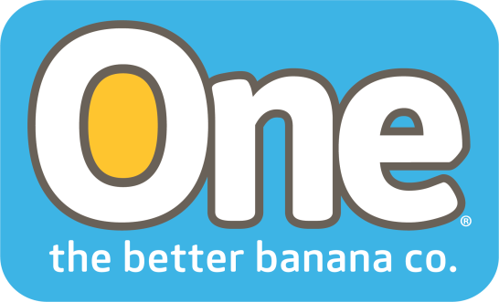

One Banana 2017 Living Wage Program Fighting Poverty in Guatemala
Coral Gables, Florida. August 2018 – One Banana, a family-owned tropical fruit operation with farms and packing plants in Central and South America, recently released the results of their sustainability programs for 2017. One of the highlights of this report is their Living Wage program.
This program aligns with the U.N. Sustainability goal #1: To eradicate poverty in all of its forms continues to be one of the main challenges faced by humanity.
The Living Wage program defines the income that an individual requires to support his/her family at a given moment and in a specific place to allow that individual to live a full and decent life. The concept of a Living Wage goes beyond that of a minimum wage, which covers only basic subsistence needs.
The calculation of the Living Wage was established through a study conducted in the Southwestern region of Guatemala. The study was done with the assistance of a specialized firm that combined worker income data with information on their expenses in the communities where they live. In December 2017, One Banana average wages exceeded the living wage in Guatemala by 16 percent and exceeded Guatemala’s per capita GDP by 81 percent.
“This research effort and its outcomes have made it possible for us to better understand the sociocultural reality of our workers and their families and to determine the direction and approach of our sustainable development projects,” said Robert Adams, President of One Banana.
Jorge Giovanni Casimiro López has worked for One Banana for the past fourteen years. “Because they pay more than just the minimum wage I’ve been able to provide for my family, send my children to school, own my own home, and buy myself a motorcycle for transportation,” says López. “None of this was possible in any of my previous jobs.”
López praised the company for their vision and their commitment to the community. “This company is an example to others. My son is given a banana to eat every day at school and my wife receives preventive health classes, all thanks to One Banana.”
One Banana remains committed to all the U.N. sustainability goals and will continue to pursue their Living Wage programs in 2018 and beyond.

About ONE Banana
ONE Banana is a sustainable grower, shipper and distributor of tropical fruit with operations in the United States, Guatemala, Europe, Peru and Ecuador. It has emerged as a leader in socially responsible and environmentally sustainable farming. For more information about ONE Banana please visit our website. https://www.onebananas.com
Contact Info:
info@onebananas.com

