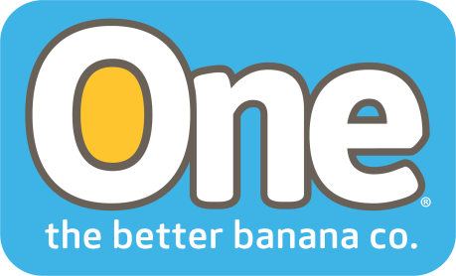
ONE BANANA CSR programs in step with the U.N. SDGs
CORAL GABLES, FLORIDA, May 15 2018 – The 17 United Nations Sustainable Development Goals (SDGs) lay out a framework for addressing the most pressing issues on the planet by 2030. ONE Banana, the better banana company has aligned their Corporate Social Responsibility programs with these goals, so that their efforts to promote economic development, gender equality, health, education, sustainable communities, natural resource conservation, measures to adapt to climate change and responsible management will contribute to the United Nations vision in the countries where One Banana operates.
ONE Banana’s corporate social responsibility projects include providing access to medical clinics, nutritional programs, and education that have benefited more than 19,500 people, across 13 rural communities in Guatemala and Peru. “We believe that when all our co-workers are treated with dignity and respect, earn a Living Wage, and have access to healthcare and education it strengthens their communities as well as improves our competitive advantage and our business potential,” says Fernando Bolaños, from ONE Banana.
The UN Sustainable Development Goals
Goal # 1 End all poverty everywhere. ONE Banana has created more than 9,000 jobs in their banana operations throughout the year. These employees all benefit from the Living Wage program, the first of its kind in Guatemala. This program established what constitutes a living wage, so that every employee can earn sufficient to provide for their basic needs – not just their biological needs. According to the UN, eradication of poverty is only possible through stable and well-paid jobs.
Goal # 2: End hunger, provide food security and adequate nutrition. Food insecurity and hunger are closely associated with lack of attention, retention and repetition of school.
The “A Banana a Day Makes a Difference” program provides free bananas to school children in the areas around their operations in both Guatemala and Peru. Bananas are a healthy snack and they are one of the only foods that contain six major vitamin groups, as well as minerals such as potassium and manganese. These programs have had a significant impact on school performance and reducing the number of children who are showing signs of malnutrition.
ABOUT ONE BANANA
ONE BANANA is a sustainable grower, shipper and distribution company with operations in the United States, Guatemala, Europe, Peru and Ecuador. It has emerged as a leader in socially responsible and environmentally sustainable farming. www.onebananas.com

